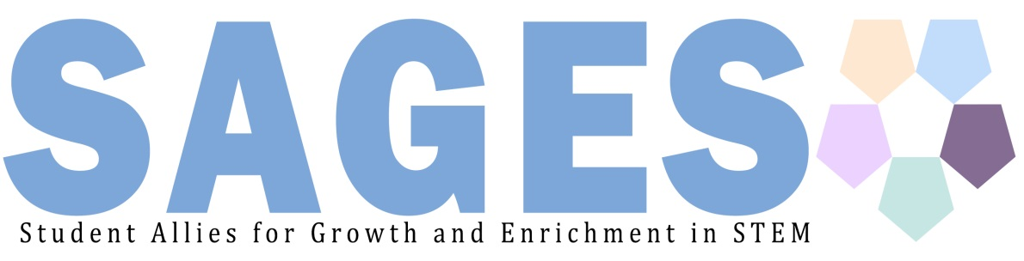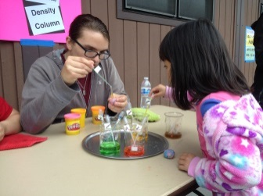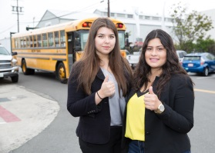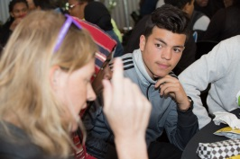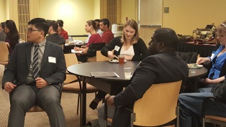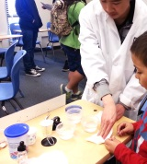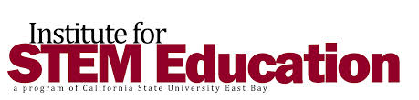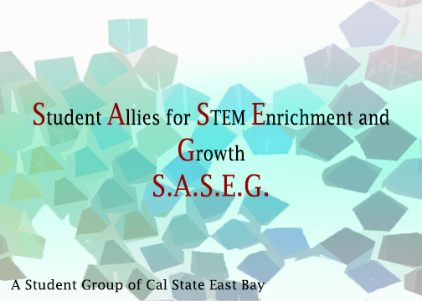

**Find us online at:**

[wwwsagesstudentgroup.weebly.com](http://www.sasegstudentgroup.weebly.com)

**Find us on Facebook at:**

<https://www.facebook.com/groups/SASEG.CSUEB/>

**Email us at:**

[sagescsueb@gmail.com](mailto:sagescsueb@gmail.com)

**Advance**

**Support**

Inspire

Our Goals

**Provide**a conduit between students at Cal State East Bay and STEM professional fields, merging development of professional and social skills with opportunities for direct interactions with local industry leaders, volunteer organizations, and municipal bodies.  
  
**Sustain** strong connections among SAGES with mentorship, guidance, and fun group events, building vital relationships between upper and lower classmen in the group.   
  
**Support** members with academic assistance and advising, utilizing campus programs to fortify their higher education experience and help them maintain their academic goals.  
  
**Participate** in local efforts to nurture the cradle-to-career continuum, bringing a brighter future to local PreK-12 students. SAGES will aid in the effort to close the achievement gap for youth in underserved communities, increasing the accessibility of STEM higher education and promoting career-preparedness.   
  
**Rely** on fellow group members when support is needed, building a positive network of friends and cohorts to help maintain personal well-being, while also building community.   
  
**Develop** professional and social skills and gain a better understanding of STEM professions, STEM education, and STEM’s practical applications.

**The capstone event for SAGES members is an end-of-year presentation to the Board of Directors at the Institute for STEM Education.**Members who have remained active in the group and met all requirements will have the opportunity to present their efforts, experiences, and what they have gained from participating in the group. In return, successful members will receive a letter of recommendation and certificate of achievement from the Institute for STEM Education, as well as a fun, end-of-year social event!

logo

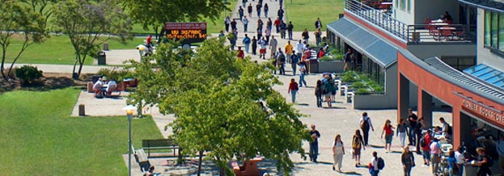

# **About Us**

# **The mission** of the

# Student Allies for

# Growth and Enrichment in STEM student group is to assist students at California State University, East Bay in pursuing their academic aspirations and career paths, while also fostering a more personalized experience in higher education through community service. By working with the Institute for STEM Education, SAGES will provide opportunities to explore and prepare for the vast array of professions which involve STEM-educated professionals; members get a glimpse of what they can do with their college degree! By amalgamating direct involvement in community service, campus events, professional development workshops, Pre K-12 outreach and student-faculty mentorship, SAGES seeks to create useful, relevant connections between STEM-focused students and their future goals.

# Supported by the Institute for STEM Education in conjunction with other organizations on and off campus, SAGES members will bolster their higher education with academic and professional support, while also engaging in a larger effort toward improving the community by making STEM education accessible to all.

Our Three Areas of Focus

**Our vision is defined not only by what our members will gain from participating in SAGES, but also by the service and support our members can provide*. It was Mahatma Gandhi who said, “The best way to find yourself is to lose yourself in service to others.”*   
With this spirit in mind, student members of SAGES will become involved in a greater effort to improve the community along with advancing their own aspirations. SAGES members will connect with on-campus and community programs by choosing to volunteer their participation in any or all of three Areas of Focus:**

|  |  |  |
| --- | --- | --- |
| Pre K-12 Involvement  **SAGES members will have the opportunity to engage in projects which nurture the cradle-to-career continuum.**  Through programs offered by the Institute for STEM Education, members will receive training and experience working with Pre K-12 students of all levels and backgrounds, and ultimately assist in the effort to bring higher education to young students in the local area.   SAGES members will also have access to participating in the Circle Labs, a new set of learning facilities which brings local STEM experts and industry leaders directly to the public with free workshops and lectures! Working with our faculty advisor Dr. Danika LeDuc and others, members get hands-on experience using newly-developed K-12 STEM curriculum | Professional Development  **Professional development lies at the heart of SAGES’s goal to assist students.** Members will have access to professional development trainings and internship/employment resources offered on and off campus.  Working closely with the Institute for STEM Education and the Academic Advising and Career Education programs, members will gain technical experience, exposure professional networks, and career-goal guidance from leaders in the fields of STEM   SAGES members will also have the opportunity to volunteer for the Hayward STEM Career Awareness Day, an all-day event in which 200+ participating high school students are taken to local businesses in the STEM fields, ranging from music studios to biotech companies! | Academic support and mentor-ship  **Mentorship between upper and lower classmen members is a fundamental component of SAGES.**   By remaining closely involved with one another, and engaging in campus academic support such as the Student Center for Academic Achievement, SAGES members will have a more positive, relevant college experience!   Members will have the ability to seek advice and assistance from their Area Leaders and fellow members regarding academic support and maintaining personal well-being during their studies. |
|  |  |  |

**What is STEM?**STEM stands for Science Technology Engineering and Mathematics. As members of SASEG, we support and participate in a variety of events, many of which involve the advancement of STEM education in PreK-12 and beyond. SASEG strives to redefine the understanding of STEM careers and education, enriching our own academic journey as well as others.

**We partner with the Institute for STEM Education to bring our members opportunities offered throughout the Bay Area.**

**Find out more about the Institute for STEM Education at**

**www.csueastbayistemed.com**

## Event Schedule