Supplies needed:
- Copies of science books | - DNA extraction: Rubbing alcohol, dish soap, strawberries large test tube
- Elephant toothpaste: 6% Hydrogen peroxide, empty plastic bottle, funnel, round pan, safety glasses, dish soap, food coloring, yeast | - Oobleck: (corn starch, water, food coloring)
- Quizzes | - Paper, glue, markers, etc.
- Water, tape | - Salt, sieve, spoons, sandwich bags, tweezers

Agenda 9/29
10:00-10:20 Quiz
10:20-10:35 Concluding discussion
Go around the circle and spend 5 minutes addressing the following: three things you learned, one thing you think is important to know from the class and why (if nothing was important, why so?), and finally what you liked and didn’t like about the class. Very briefly, only 2 minutes per kid, share ONE of these points with the group.
10:35-10:55 Science spree!
Students can choose to do Oobleck, DNA extraction (one person at a time or in a team/pair), and construct their own artistic science recipe book to take home. Everyone will get to see the Elephant toothpaste. Check on Chinampa.

DNA Extraction from Fruit
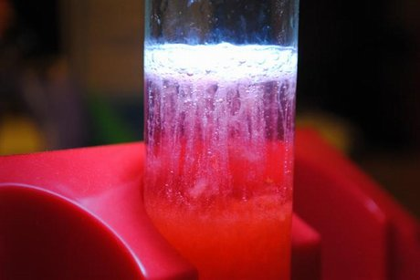
Materials
- Strawberry, others
- Isopropyl alcohol (5 mL)
- Dish soap (10 mL)
- Salt (1/4 tsp)
- Zipper-lock bag
- Sieve
- Water (90 mL)
- Measuring utensils
- Beakers or similar containers
- Tweezers
- Pipette (optional)
- Spoon

EXPERIMENT
- Put a bottle of isopropyl alcohol in a freezer. We'll come back to it later.
- Measure 90 mL of water into a beaker or similar container.
- Pour 10 mL of dish soap into the 90 mL of water.
- Add 1/4 tsp of salt to the liquid in the beaker.
- Mix it all up and now you've got a homemade extraction solution!
- Place one strawberry in a plastic zipper-lock bag.
- Pour your extraction solution into the bag with the strawberry.
- Remove as much air from the bag as possible and seal it.
- Use your hands to mash the strawberry inside of the bag until there are no large pieces remaining.
- Pour the resulting strawberry and extraction solution mixture through a sieve and into a beaker or similar container.
- Use a spoon to press the strained bits of strawberry against the sieve, forcing even more of the solution into the beaker.
- From the container it is currently in, transfer the solution into a smaller beaker or similar container that holds around 50-100 mL of fluid.
- Add 5 mL of your chilled isopropyl alcohol to the solution and hold the mixture at eye level.
- Can you see how there is a separation of white "stuff" atop the rest of the solution? That's the DNA of the strawberry.
- Gently remove the DNA from the solution using tweezers.

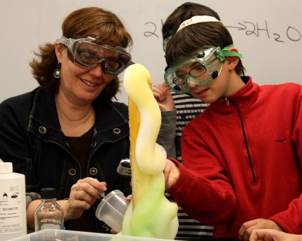
Elephant Toothpaste
Materials

- 16 oz empty plastic soda bottle (preferably with a narrow neck such as those made by Coca-Cola)
- 1/2 cup 20-volume hydrogen peroxide (20-volume is 6% solution, purchased from a beauty supply store)
- Squirt of Dawn dish detergent
- 3-4 drops of food coloring
- 1 teaspoon yeast dissolved in approximately 2 tablespoons very warm water
- Funnel
- Foil cake pan with 2-inch sides
- Safety glasses
- Lab smock

EXPERIMENT

- Put on their safety glasses and lab smock. Have in front of you a cake pan, plastic bottle, Dawn in small cup, food coloring, 1/2 cup peroxide, and the dissolved yeast mixture.
- Stand the bottle up in the center of the cake pan. Put the funnel in the opening. Add 3-4 drops of food coloring to the peroxide and pour the peroxide through the funnel into the bottle.
- Add the Dawn detergent to the peroxide in the bottle.
- Pour the yeast mixture into the bottle and quickly remove the funnel.
- You can touch the bottle to feel any changes that take place.

http://www.stevespanglerscience.com/lab/experiments/elephants-toothpaste

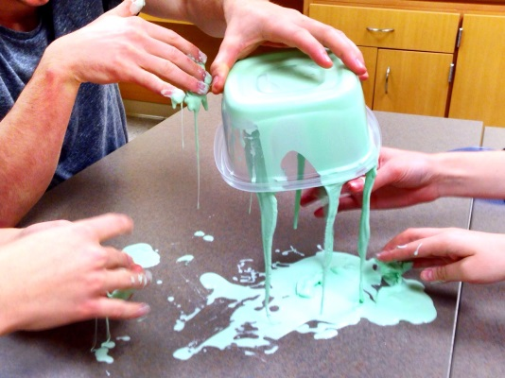
Oobleck

Materials
- water
- corn starch
- food coloring (optional)

Experiment

- Mix 1 part water with 1.5 to 2 parts cornstarch. You may wish to start with one cup of water and one and a half cups of cornstarch, then work in more cornstarch if you want a more 'solid' oobleck. It will take about 10 minutes of mixing to get nice homogeneous oobleck.
- Mix in a few drops of food coloring if you want colored oobleck.
http://chemistry.about.com/od/chemistryhowtoguide/ht/oobleck.htm

